Assessment task 3

Ciarán Maher 30/11/2015
System Investigation, High Level Requirement Report and Feasibility Report

Contents
System Investigation 3
DFD Level 0 3
DFD Level 1 4
DFD Level 2 5
High Level Requirement Report 6
Feasibility Report 7

System Investigation

DFD Level 0
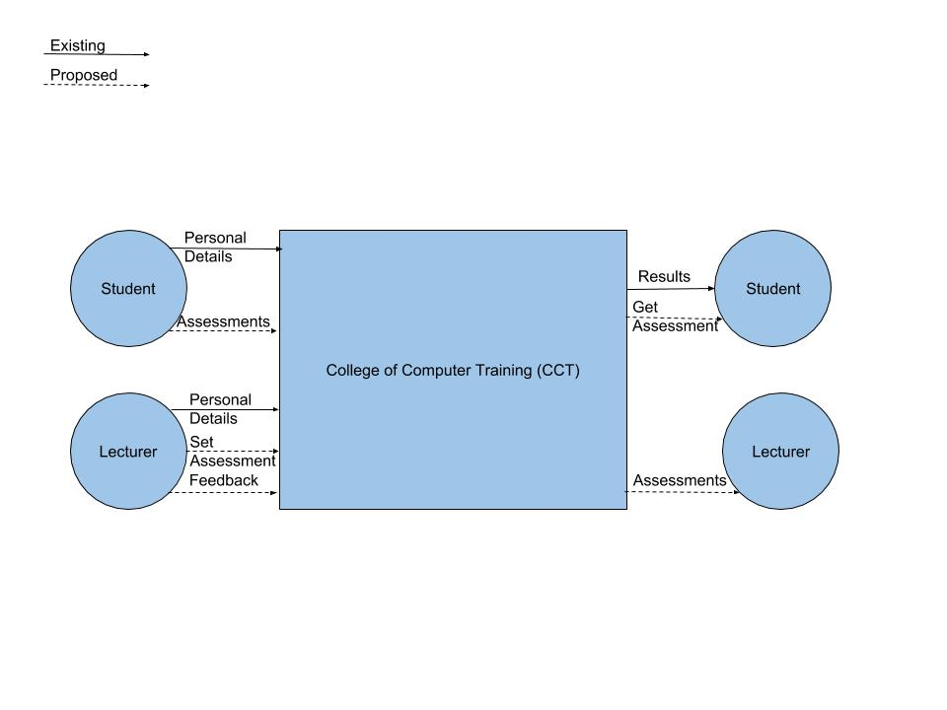

DFD Level 1
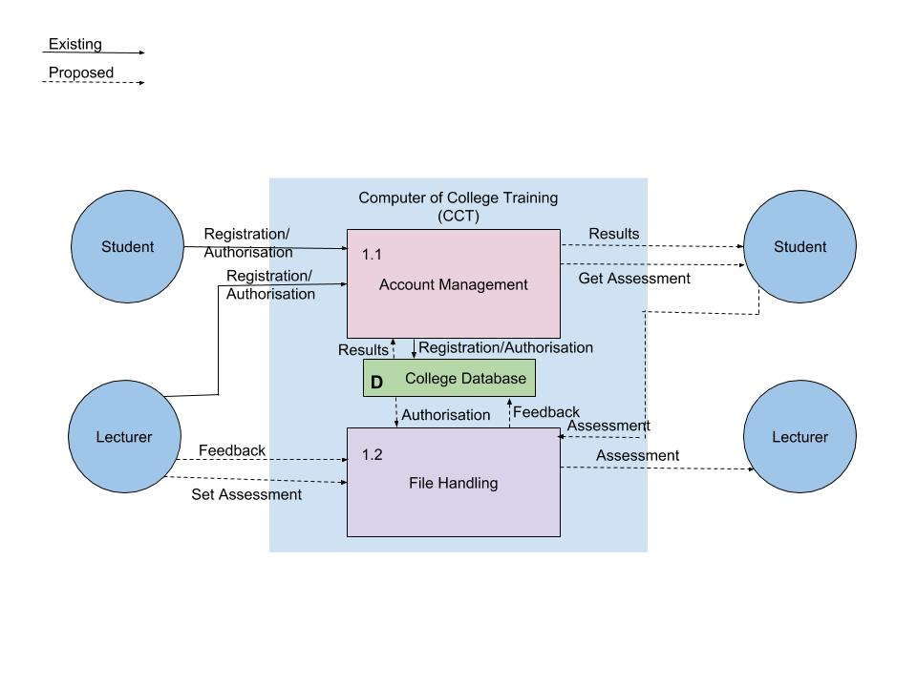

DFD Level 2
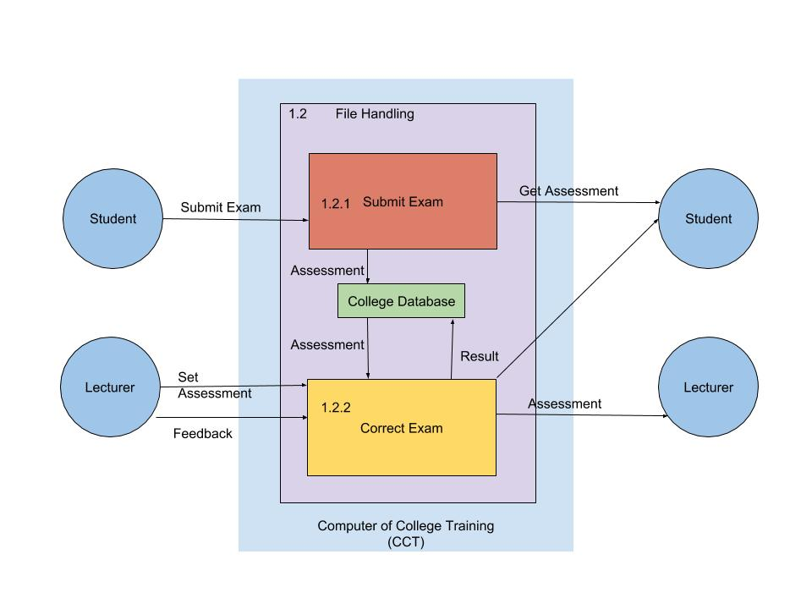

High Level Requirement Report
Requirements Catalogue Entry
System: | College of Computer Training (CCT) E-submission system | Date: | 1st-December-2015
Author: | Ciarán Maher | Page: | 1/1

Functional Requirement
Req No: | 2.0
Description:
New functionality added to the existing system, to allow students to electronically submit their
Assessments online. This system will also allow lecturers to log-in remotely, provide feedback to
Students and have students notified of that feedback.

Non-Functional Requirements
Registration and authorisation system has already been implemented and is intended to be
complimented by this new system. A student should not be able to access any assessments that
were not submitted by them and lecturers should only be able to access and provide feedback on
assessments from students in their class. Feedback should be stored alongside existing user
Information and accessible at all time.

Related Documents
DFD System Design Level 0/1/2
Feasibility study report
Design Brief

Suggested Solution(s)
Purchase pre-existing software solution from a 3rd party vendor
Develop a new solution for e-submission; ranging from allocated storage space on a central mainframe to email submissions.

Actual Solution
Expand upon existing account management system to allow for online submissions, from any
where and at any time.

Feasibility Report
Feasibility Study
System: | College of Computer Training (CCT) E-submission system | Date: | 1st-December-2015
Author: | Ciarán Maher | Page: | 1/1

Product
This product can be developed, maintained and supported using existing in-house technologies
and skillsets.

Technical Feasibility
Infrastructure is largely already in place, with the existing account management
system that has already been implemented.

Social Feasibility
Development team are excited to finally expand upon the existing account management system,
as well as address pre-existing bugs that have remained since initial launch.

Market Research
This is one of the most requested features from both Students and Lecturers. Reducing all
paper-work, physical data storage and ensuring our organisational policies adapt with
emerging technologies.

Economic Feasibility
Using internal skillsets, this project would save the College of Computer Training (CCT) several
thousand euro in paper per year. Initial estimates fall within budgetary allowances for
Developing new technologies.

Alternative Solution
Purchase pre-existing software solution from a 3rd party vendor
Develop a new solution for e-submission; ranging from allocated storage space on a central mainframe to email submissions.

